Name: | Chanceller Waters
Assignment: | Module 4.2 Test plan
Project: | Todo App Test plans
Course: | CSD-380 : Devops
Description | : Functional test plan for the Todo Application based on the document listing business requirements. Requirements include: URL access, Task list viewing, task creation, task editing, task deletion, form validation, invalid URL handling, and mobile/tablet aesthetics.
Date: | 2026/01/07

.
TABLE OF CONTENTS
Test 1:.. 2
Test 2:.. 3
Test 3:.. 4
Test 4.. 5
Test 5:.. 6

Test 1 | Website access and task list view
 | Test Objective: verify that users can access the todo application through its associated URL and view existing items. | Developer: Chanceller Waters  Date tested: 2026/1/07 | Peer tester: Caleb Schumacher  Date tested: 2026/07/05
Step | Action | Expected results: | Developer pass/fail | Tester pass/fail  + Screenshot
1 | Visit  https://buwebdev.github.io/todo/ | Todo App loads without error | Yes | Yes
2 | Verify that the page header/navigation displays Todo and the welcome message is visible | Landing page content is visible and readable | Yes | Yes
3 | Verify that the Task form section displays an input field for new tasks and an " Add Task " button to submit those tasks | The task entry field is present on the page | Yes | Yes
4 | Verify that Todo List is populated with several sample task items | Task list is visible with preexisting todo items that can be edited or deleted | Yes | Yes
5 | Refresh or F5 to reload the browser window | Application reloads to the same URL, and the preexisting Todo list is visible in its original state | Yes | Yes  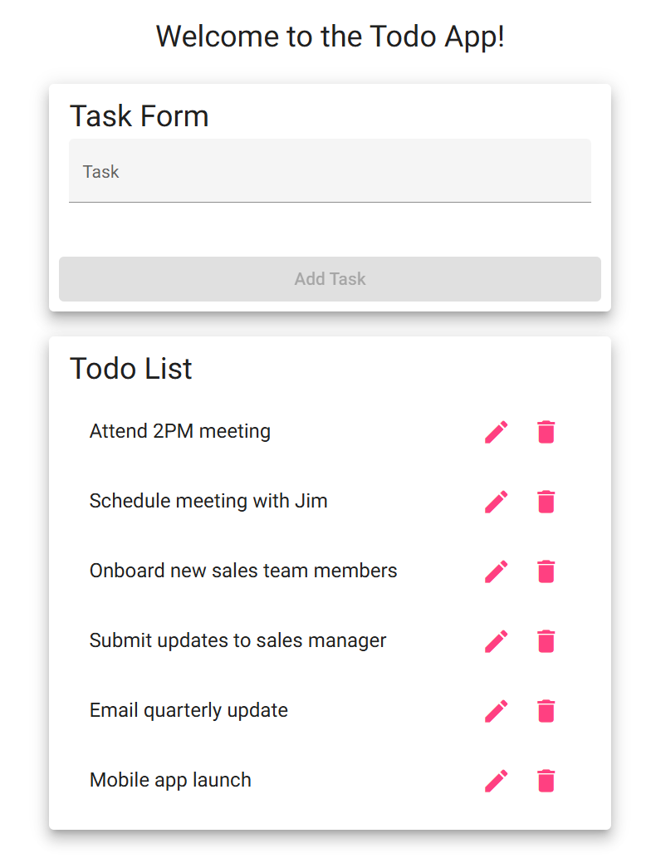
Comments | The test confirms that the application can be reached via its associated URL and that the initial list loads without error. Associated elements(task input field and sample task items) are visible and persist with a refresh of the page

Test 2 | “Add” form Validation
 | Test Objective: Verify that a new task form cannot be submitted without a todo item in the field | Developer:  Date tested: <yyyy/mm/dd> | Peer tester: Caleb Schumacher  Date tested: 2026/07/05
Step | Action | Expected results: | Developer pass/fail | Tester pass/fail
1 | Open the todo application and leave the task input field empty | The task form is displayed, but the task text field remains empty | Yes | Yes
2 | Attempt to add the blank task form or verify that the add task button is still inactive | Blank task is not added to the Todo list | Yes | Yes  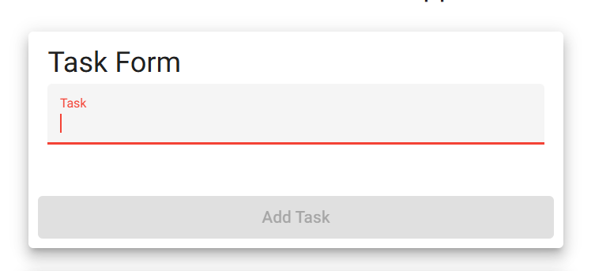
Comments | Test confirms that the add form does not accept empty or blank tasks. This

Test 3 | Create a Todo task
 | Test Objective: Verify that a user can create a new to-do list item | Developer:Chanceller Waters  Date tested: 2026/01/07 | Peer tester: Caleb Schumacher  Date tested: 2026/07/05
Step | Action | Expected results: | Developer pass/fail | Tester pass/fail
1 | Travel to  https://buwebdev.github.io/todo/  And Enter a task with a length of 4 or more characters into the task input field | Task text appears in the task input field | Yes | Yes  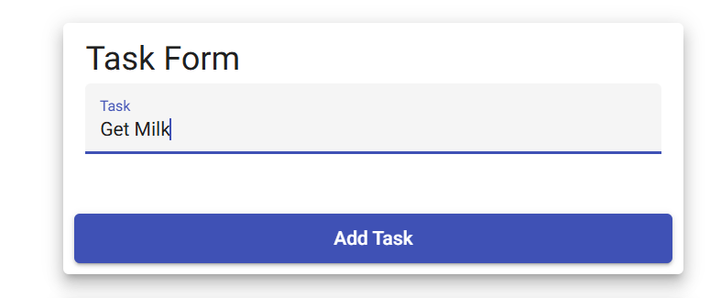
2 | Click on the add task button | The new task is populated in the to-do list | Yes | Yes  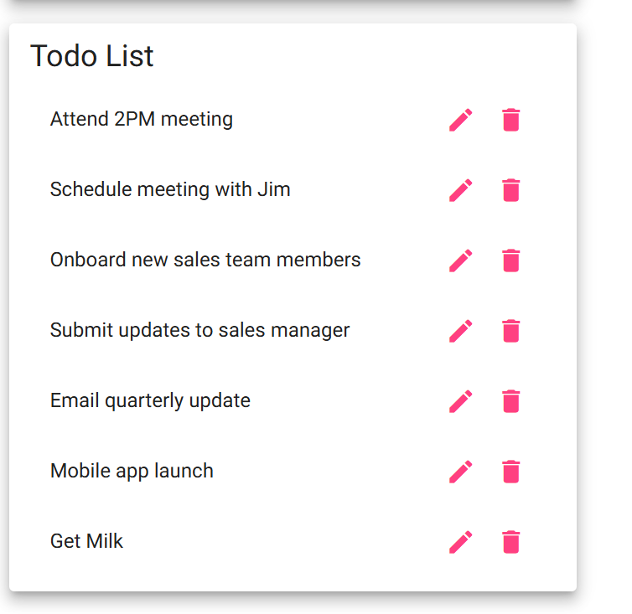
3 | Verify that the todo is updated and the task form is available for another submission | The application allows for subsequent submissions | Yes | Yes  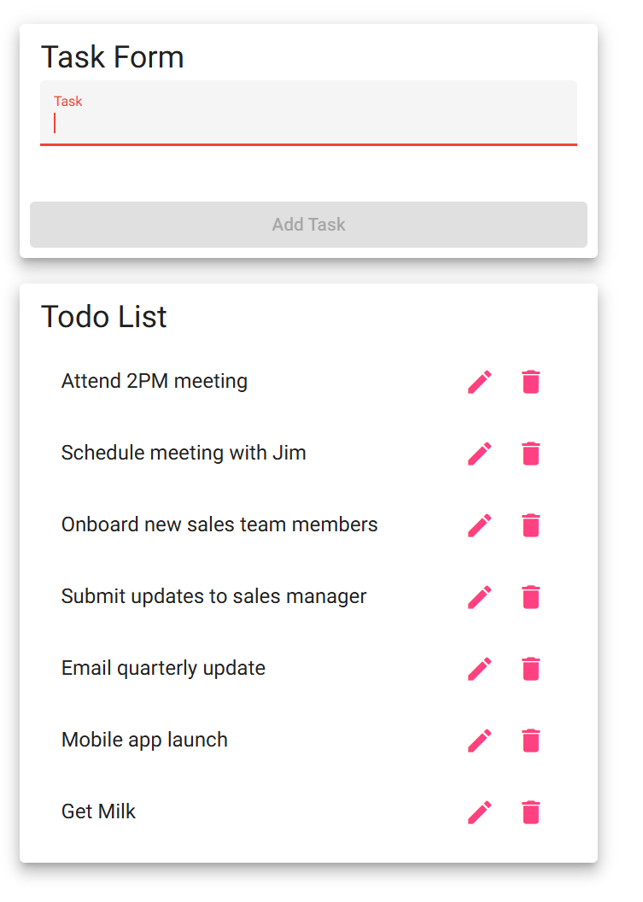
4 | Enter a todo task with fewer than 4 characters | The add task button remains inactive | Yes | Yes  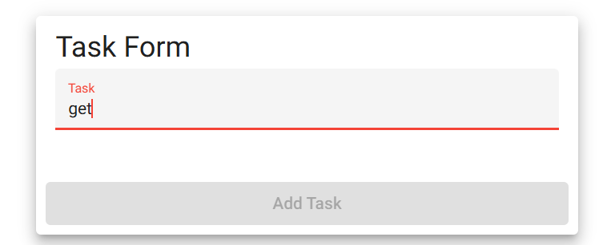
5 | Enter blank spaces numbering 4 or more into the task input field and click " Add task” | The application should leave the add task button inactive. The application should reject the empty todo item  No empty todo item should populate the list | No | No  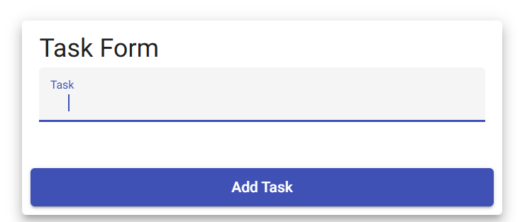
Comments | Test confirms that users can add a new task to the todo list and that the list can accept submissions afterward. This test that the list can be updated and primed rather than allowing one-off submissions. Observed that users can submit blank to-do list items by submitting tasks composed of blank spaces. This goes against validation expectations. This can be corrected by parsing out blank entries or filtering for unnecessary blank spaces before populating the list.

Test 4 | Edit Todo Task
 | Test Objective: test edit function for the todo application. Tests whether uses can edit items and save them without changing the list order | Developer:Chanceller Waters  Date tested: 2026/01/07 | Peer tester: Caleb Schumacher  Date tested: 2026/07/05
Step | Action | Expected results: | Developer pass/fail | Tester pass/fail
1 | Travel to https://buwebdev.github.io/todo/ | Landing page loads without issue | Yes | Yes
2 | Click the edit icon next to a sample or added task | The edit form opens and displays the selected task for editing | Yes | Yes  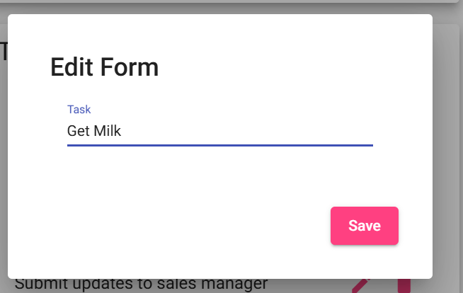
3 | Edit the task input | Changes to the todo list item are reflected in the edit form input section. | Yes | Yes
4 | Click “Save” | Edit form closes, and the todo list is updated with the edited task | Yes | Yes
5 | Verify list is updated with new changes | Edited task takes the place of the previous one in the same position | Yes | Yes  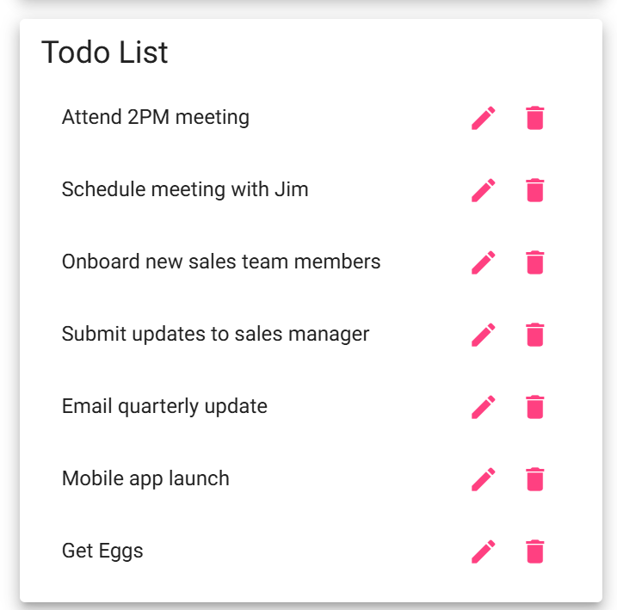
Comments | Confirms that the application allows for editing of existing or added todo list items. Edit form opens without issue. Text is editable. Text is updated to list without changing list order.

Test5 | Delete Todo task
 | Test Objective: verify that users can delete existing or added tasks from the todo list | Developer:Chanceller Waters  Date tested: 2026/01/07 | Peer tester: Caleb Schumacher  Date tested: 2026/07/05
Step | Action | Expected results: | Developer pass/fail | Tester pass/fail
1 | Travel to https://buwebdev.github.io/todo/ | Application loads successfully | Yes | Yes
2 | Select a task, either preexisting or recently added | All tasks are visible and readable | Yes | Yes
3 | Click the delete icon | Selected item is removed from the list | yes | Yes  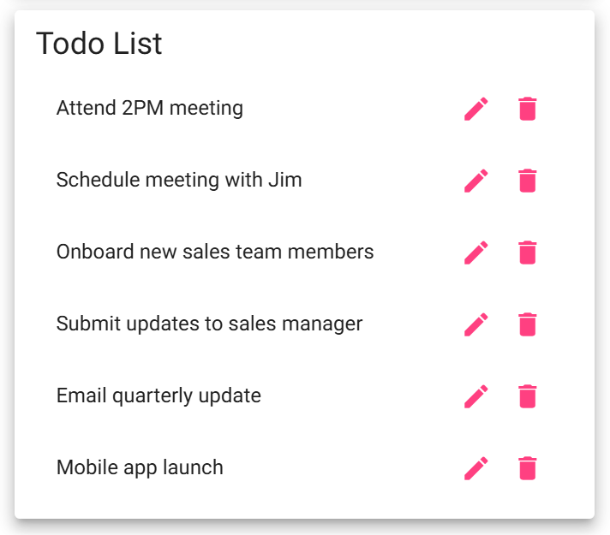
4 | Verify that the selected item was removed from the to-do list | The item is no longer visible, and the list spacing is adjusted to reflect this change | Yes | Yes
5 | Refresh the page to see if preexisting items will return | Sample items should be repoulated, and added items will be removed. List returns to the sample state | Yes | Yes
Comments | Confirms that items are deleted with a click of a button. Confirms sample items reload when refresh is done. A confirmation function should be added to prevent accidental task deletions.

